THERMAL REGIME OF ANNUAL AIR TEMPERATURE IN BOSNIA AND HERZEGOVINA

Nusret Drešković
Associate professor
University of Sarajevo, Faculty of Science, Department of Geography
Zmaja od Bosne 33 – 35, Sarajevo, Bosnia and Herzegovina
e-mail: nusret2109@gmail.com

Ranko Mirić
Associate professor
University of Sarajevo, Faculty of Science, Department of Geography
Zmaja od Bosne 33 – 35, Sarajevo, Bosnia and Herzegovina
e-mail: rmiric@gmail.com

UDK: 551.584:911.62:914.971.5
COBISS: 1.01

Abstract
Thermal regime of annual air temperature in Bosnia and Herzegovina
Horizontal air temperature is defined by the value of the mean air temperature for a certain surface area unit. It is defined by the value of horizontal thermal gradient, i.e. the value of average change of horizontal temperature per unit area. In order to define the horizontal change of air temperature in Bosnia and Herzegovina, a GRID thermal model was constructed whose spatial resolution is 20 m. Based on obtained thermal model geo-database it was determined that the mean annual air temperature for the whole area of Bosnia and Herzegovina is about 10.9 °C, keeping in mind that there are significant thermal differences with respect to the two existing climate zones. More specifically, on the territory of the northern temperate climate zone the average annual temperature is about 9.7 °C, while in the Mediterranean climate zone the said value is 12.1 °C.
In this work, it was also found that thermal contrasts are very pronounced as well, due to the fact that average annual temperature in the highest mountain peak zones in southeastern Bosnian highlands is negative and is found to be -1.4 °C (Maglić peak), while at the Neum coastal zone it is measured at 15.9 °C. The above stated pronounced thermal contrasts are determined on a small horizontal distance, as a consequence of climactic position of Bosnia and Herzegovina as well as highly pronounced terrain dynamics.
Keywords
Bosnia and Herzegovina, horizontal thermal gradient, GRID thermal model, climate zones, average annual air temperature

Uredništvo je članek prejelo 5.12.2017
1. Introduction

Bosnia and Herzegovina is located at the central part of the northern temperate climate zone, i.e. between 42º N and 45º N and 15º E and 19º E. Maximum meridian stretch of Bosnia and Hercegovina is about three arc degrees, and close to four arc degrees by latitude. The 45th parallel passes through the far northern areas of the state territory (north of the towns of Cazin, Prijedor and Derventa), and due to this fact Bosnia and Herzegovina is situated closer to the Equator relative to the geographic North Pole. With respect to the continental spatial position Bosnia and Herzegovina represents a transitional region between southern parts of the northern temperate climate zone and northern parts of the northern sub-tropical climate zone (Fig. 1). Spatial position of the said climate boundary – zone coincides with orographic boundary represented by the peaks of central BiH Dinarides: Plješevica (1,646 m) at the north-northwest, Osječenica (1,795 m), Klekovača (1,961 m), Vitorog (1,905 m), Raduša (1,955 m), Bitovnja (1,742 m), Bjelašnica (2,066 m), Treskavica (2,086 m), Lelija (2,032 m), Zelengora (2,014 m), Volujak (2,336 m) and Lebršnik (1,985 m) at the east-southeast of Bosnia and Hercegovina.

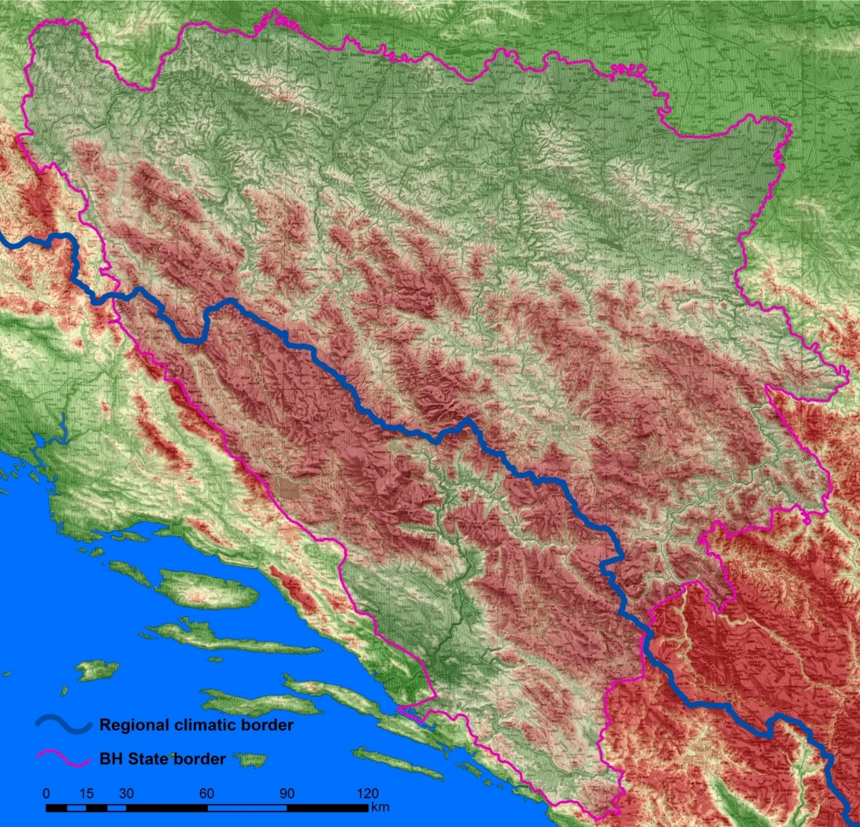

Fig. 1: Spatial position of the climate boundary on the territory of Bosnia and Herzegovina.
Under the influence of above mentioned main climate zones and primarily with respect to landform predispositions of the terrain on the territory of Bosnia and Herzegovina there is intertwining and mixing of air masses with significantly different physical characteristics. More specifically, over its territory air masses of westerly circulation rich in humidity are interchanging with mainly dry air masses from the east and northeast of the continent, as well as with polar maritime air from the north and sub-tropical mass from the African north. This situation directly reflects on the radial circulatory processes, resulting in formation of a large number of local thermal and other climactic specificities in general. It is also important to highlight that Bosnia and Herzegovina is in the shape of a triangle whereby one of the arms stretches in the east – west direction, the other in the north – south direction while the hypotenuse stretches in the northwest – southeast direction and lies almost parallel to the coastal line. In this way Adriatic Sea has a significant influence on the thermal regime of the area situated to the south-southwest of the said climate boundary.

2. Spatial distribution of annual air temperature in Bosnia and Herzegovina

By analyzing the overall geo-database of the thermal model for annual temperature we come to the result that the average annual air temperature for the territory of Bosnia and Hercegovina is about 10.9 °C, keeping in mind that there are significant differences with relation to the two existing climate zones. More specifically, on the territory of the northern temperate climate zone the average annual temperature is about 9.7 °C, while in the Mediterranean climate zone the said value is 12.1 °C (Drešković, Mirić 2016, 53). Thermal contrasts are very pronounced, due to the fact that average annual temperature in the highest mountain peak zones in southeastern Bosnian highlands is negative and is found to be -1.4 °C (Maglić peak), while at the Neum coastal zone it is measured at 15.9 °C. It is important to emphasize that the stated temperature difference of about 18.0 °C is established at the horizontal distance of 85.5 km by air (Maglić peak - Župski gulf), i.e. 0.21 °C/km, which is by more than 30 times more pronounced than the average horizontal temperature change on the northern hemisphere. This climactic specificity is a consequence of morphological morphometric relationships, as the altitude differences on this profile are changing on average by about 30 m/km. Relative to the Mediterranean zone, thermal contrasts in the continental climate zone are somewhat less pronounced as the temperature difference in terms of average annual temperatures is smaller – about 16 °C. Horizontal temperature decrease is about 0.07 °C/km, with the altitude related variation also being less pronounced – about 12.9 m/km.

A very illustrative indicator of the horizontal temperature change in Bosnia and Hercegovina are its changes in the overall transverse and longitudinal profile. For this purpose, two lines have been constructed for the two temperature profiles on the thermal model for average annual air temperatures:
- Mali Ston Canal – Drina river estuary into the Sava river – transverse profile,
- Maglić Mountain – Glina river (Ponikva settlement) longitudinal profile.

Both profile lines are constructed (as indicated before) on the thermal model with a very high resolution (20-meter GRID) which is why the resulting profiles are very detailed and show all the temperature changes on the 20 m x 20 m cell size (Drešković 2012, 96). This fact is an explanation for the very pronounced temperature oscillations on the graph lines, which for the purpose of real representation, have not been additionally statistically adjusted. Transverse thermal profile was drawn from the middle of the Mali Ston Canal and further over the Neum gulf and inland (Žaba mountain), Hutovo blato, Dubravska lowland, Velež mountain, northwestern slopes of the Crvanj mountain, Visočica mountain, western slopes of the Bjelašnica and Igman mountains, Trebević mountain, Sarajevo, Ozren and Bukovik mountains, western slopes of the Šljemenska mountain as well as Javor and Javornik mountains, Spreča river valley, Majevica mountain, Sapna river valley, Visoka Glava hill, Bijeljina and Brodac all the way to the Drina river estuary into the Sava river. The total length of the profile by air is about 262.5 km, with the length of the topographic profile being multiple times greater.

From the presented graph for the transverse profile an average temperature variation along the profile zone in the range from 3.0 °C to 15.5 °C can be determined, which is fairly representative due to the fact that the profile line is positioned to the west of the southeastern Bosnian highlands zone. One of the main conclusions which can be drawn from the analyzed graph is that the profile line has a mainly opposite shape to the morphologic morphometric changes in the terrain of the region through which the profile zone passes. More specifically, looking at the profile the already presented theoretical statements on the decrease of average annual temperature relative to the growing altitude above sea level on the territory of the whole of Bosnia and Hercegovina by an average of about 0.55 °C/100 m can fully be confirmed, so that higher hypsometric levels relate to lower temperature and vice versa.

Longitudinal thermal profile is located covers the area northwest of the Mount Maglić peak, over Trebova mountain, Lelija mountain, Treskavica mountain, Bjelašnica mountain, Zujevina river valley, northwest slopes of the Bitovnje planine, Pogorelica, Zec mountain and Vranica Radovan mountain, Komar mountain, southwestern slopes of the Radalj mountain, Jajce, Plivsko lake, Mrkonjić Grad, Manjača mountain, river Sana valley (at the Donje Sokolovo settlement) and further on southwest of the Sanski Most, Majdanska mountain, Una river valley (at the Ivanjska settlement), Mašena Glavica, Bužimica river valley (at the Čaglice settlement), Gladno Brdo up to the Glina river valley (at the Ponikve settlement). Given that this profile line passes through Bosnia and Hercegovina in the direction of the Dinarides, its length by air is greater and is about 317 km. General characteristics of the temperature profile are conceptually fully in accordance with the views stated regarding the pervious profile. The only difference is in the temperature variation range since it is somewhat more pronounced with respect to the longitudinal profile zone: from 1.5 °C to 14.5 °C. It should certainly be noted that this is in part due to the fact that the profile line of this profile is not linked to the actual peak of the Maglić Mountain but rather it is positioned to the northwest of it, thus offsetting the stated variation by about 1.0 °C.

It is also important to underline that there are certain differences related to the trend of spatial air temperature change from one to the other part of Bosnia and Hercegovina. More specifically, in the profile from Neum towards Brčko, the air temperature first has a general decreasing trend from 15.6 °C to about 3.0 °C (first 95 km), from which point the general temperature trend has an increasing tendency to about 14.0 °C. In the longitudinal profile a general continual increasing trend of air temperature from about 2.0 °C (in the Mount Maglić zone) to about 14.5 °C in the wider region of the town of Velika Kladuša can be identified.

3. Annual isothermal regime in Bosnia and Herzegovina

The main thermal characteristic which can be seen in the course of the annual air temperature on the whole territory of Bosnia and Herzegovina is the existence of only one distinct temperature maximum and minimum which occur on average one month following the Sun’s solstice positions. More specifically, maximum air temperatures occur during the climactic summer period of the year (June – August) with the maximum in July. The exception to this rule are the highest mountain peak zones as they are located at altitudes of above 1,900 m above sea level; temperature maximums in terms of time occurring one month further - August. Such temperature relationships are a consequence of reduced heating of the surface area at the highest hypsometric levels thus leading to the time necessary for heating up the contact surface area and accumulation of heat on the ground to be somewhat longer. It should certainly be pointed out that the month-to-month temperature differences determined in these zones are quite small ranging from 0.2 °C to 0.5 °C.

A similar situation with respect to minimum temperature extremes can be seen, as they are distributed relative to time during the winter climactic period, i.e. December – February. Minimum air temperatures occur in the month of January, while at the highest mountain zones (above the altitude boundary stated above) they are also moved to February. Month-to-month temperature differences between the extreme months in these hypsometric ranges are also fairly small from 0.1 °C to 0.3 °C.

Between the above mentioned extreme periods of air temperatures throughout the course of the year in Bosnia and Herzegovina the transition climactic seasons, spring and autumn also stand out with very similar thermal characteristics. The only distinctiveness that can be especially emphasized is that during the spring season (March – May), in accordance with the astronomical factor, the temperatures are continually increasing with the approach towards the summer period – on average by about 4.5°C to 5.0 °C, while in the course of the autumn season the opposite is true with regards to air temperatures, i.e. temperatures decrease from the beginning of autumn towards the beginning of winter with average month-to-month variations of about 5.0 °C (Drešković, Mirić 2014, 285). By analyzing a number of examples, it was also determined that the spring season is characterized by a somewhat lower average relative to the autumn average, i.e. for the whole of Bosnia and Herzegovina autumn is warmer by about 1.0 °C compared to spring.

Taking into account the highlighted main quantitative thermal indicators, a detailed analysis of horizontal variation of the annual air temperature course in Bosnia and Herzegovina was conducted based on annual isothermal regime. More specifically, special distribution of mean annual isotherms in Bosnia and Herzegovina is a result of main atmospheric action centers activities taking place during the main climactic seasons within the wider region of the European continent. Therefore, it can be concluded that the quantitative annual values of isotherms are found between the January and July analogues, i.e. analogous to the already stated indicators for the temperature extremes, their values vary within the range of 15.5 °C to -1.0 °C.

Based on the stated values a number of characteristic thermal grades may be distinguished, defined by biogeographic processes, or those significant for climactic differentiation in Bosnia and Herzegovina. Primarily, it is necessary to determine the regions in Bosnia and Herzegovina which fall within the zero average annual isotherm, which separates the regions with positive temperatures from those with negative temperatures.

The area with negative average annual temperatures (-1.4 °C to 0.0 °C ) is restricted to very narrow regions of the highest mountain peaks in the zone of southeastern Bosnian highlands above 2,200 m above sea level, i.e. at the highest terrain parts of the mountainous morphostructures of Maglić as well as Volujak and Ljubišnja. Based on this, it can be concluded that on the whole territory of Bosnia and Herzegovina values of average annual air temperature are positive (except for the above mentioned areas with practically irrelevant area contribution).

Positive average annual air temperatures are defined by three grades. The first thermal grade from 0.0 °C to 5.0 °C continues on from the preceding altitude zone (with negative average annual temperatures), i.e. it encompasses regions of the highest mountainous morphostructures of the Central Bosnia region, with average annual temperature for the whole region of about 3.2 °C (Fig. 2). Average altitude limit values of this thermal grade range from 1,200 m to 2,200 m above sea level, with average value of average annual air temperatures of 3.8 °C. Specifically, in spatial terms the above mentioned thermal range is found in the high hypsometric zone of the dominant mountainous morphostructures of the above mentioned mountains and valleys morphologic region of Bosnia and Herzegovina. The second thermal grade covers the average annual temperature values ranging from 5.0 °C to 10.0 °C. The average air temperature value for this thermal grade is about 8.0 °C, although it must be emphasized that the spatial variations are fairly pronounced which is a direct consequence of thermal continental or thermal maritime degree value of analyzed regions. Thermal characteristics of the extreme months also show significant variations. Mean July temperatures range from about 11.5 °C (Busovača municipality – wider region of the Hum Mountain) to about 21.5 °C (wider region of the town of Trebinje).

Fig. 2: Mean annual air temperatures on M.S.Bjelašnica, M.S. Pale, M.S.Sarajevo-Bjelave; M.S. Bijeljina, M.S.Mostar and M.S. Neum, in the 1960 – 1984 period.

Similar can be said for mean January temperatures, which vary from -7.5 °C to 1.4 °C, for the same regions. Average hypsometric range covered by this thermal zone is found within an isohypse of about 500 m to 1,200 m, and is spatially represented in all three geographical regions of Bosnia and Herzegovina: Northern, Central and Mediterranean.

The third thermal grade encompasses mean annual air temperature values ranging from 10.0 °C to 15.9 °C. Average air temperature for the whole area of this thermal grade is about 11.3 °C, whereby it can be said that (as opposed to the previous grade) the quantitative-spatial temperature variations are not so pronounced. Mean July temperatures range from 18.5 °C (mountainous perimeter of Ljubinje lowland) to 25.0 °C (in the zone of marine aquatorial gulf Neum – Klek). Mean January temperatures within this thermal zone also do not vary as much, i.e. its values fall between -1.6 °C (wider region of the town of Prnjavor) and 7.7 °C (also in the zone of marine aquatorial gulf Neum – Klek). With respect to spatial coverage, two separate areas of continual distribution of this thermal grade can be distinguished. The first region is situated in the Northern Bosnia region, which on the surface is continually spread over mostly lowland terrain, up to 200 m above sea level, in the morphological sub-region of Peripannonian Bosnia. Excluding the dominant (already mentioned) highland mountainous morphostructures, it can be said that this thermal grade covers all alluvial plateaus downstream (lowland) watercourse segments of the right hand side tributaries of the Sava river, i.e. wide alluvial plateaus of the following rivers: Una together with Sana, Vrbas, Ukrina, Bosna, Brka and Drina, as well as the immediate Sava river catchment. Average air temperature characterizing this area unit is about 10.6 °C, without highly pronounced spatial variations. In the Mediterranean region this zone encompasses the area of hypsometrically low lying terrain in the Neretva river valley and its larger tributaries south of Bijelo Polje, including also Mostarsko Blato and Hutovo Blato marshlands, This thermal grade also includes the larger portion of the Popovo Polje plateau, as well as karst-corrosive plateau of Brotnjo and Dubrave. The altitude limit of this zone relative to the preceding zone is represented by the limiting isotherm of 10.0 °C, which is in this region found on average at 500 m above sea level although with highly pronounced altitude deviations. In other words, thermal characteristics of this zone can be found in a zone which often exceeds the stated upper altitude limit and may reach up to 900 m (Trebinje-Bubreg – 902 m above sea level). Average air temperature in this spatial unit is about 12.1 °C.

The mentioned annual isothermal regime in the territory of Bosnia and Herzegovina is directly influenced by a series of meteorological and physico-geographical factors. The most significant influence on the quantitative values of the annual flow temperature of the air is realized by the temperature fluctuations of the characteristic months - July and January. On the level of the quantitative variations of the average air temperatures, july temperatures have the more moderate characteristics in relation to the annual value. More specifically, the average temperature values vary between 6.8°C (Maglić mountain peaks) and 24.9 °C (coastal zone of Bosnia and Herzegovina), so the total variation is 20.1°C.

According to these temperature limes and according to the analysis of the basic net of the temperature stations, it can be obtained the representative value of the average temperature for July – it is 17.4 °C for Bosnia nad Herzegovina (Fig.3). Using the analysis of the average July isotherms it can be concluded the highest mean air temperature (t ≥ 22.0 °C) is in the territory of the Low Herzegovina (elevation to 500 m) as the area of the mesoregion Posavina-Spreča-Majevica-Lower Drina Peripanon Bosnia as well (elevation to 200 m).

Fig. 3: The average July air temperatures at M.S. Mostar, M.S. Sarajevo-Bjelave, M.S. Kupres and M.S. Banja Luka, in the period from 1960. to 1984. Thermal types: hot summer, warm summer and chilly summer.

The lowest values of the mean july temperature (t < 10.0 °C) are in the hypsometric zones above 1,800 m. There are the areas of the highest mountain peaks where the land surface is very small and the air is significantly diluted as a result of which the separation from the substrate surface unit is more intense than the equivalent at low altitudes. Given the relatively low mid-July temperatures, this type of July thermal regime can be characterized as a chilly summer.

The spatial-temporal dynamics of the mid-January air temperature in Bosnia and Herzegovina is the result of the interaction of the main seasonal action centers of the atmosphere in the wider region of the European continent: Icelandic depression, Siberian anti-cyclone and arctic anti-cyclone. In general, these relations are reduced to the dominant influences of the continental interior of the Eurasian land in the continental climatic region, that is, the predominant effects of the Adriatic aquatorium in the climate region of Mediterranean Bosnia and Herzegovina. The quantitative variation of the mean January air temperatures shows similar characteristics in relation to the annual value. More specifically, the total spatial variation of the mid-January temperature is 17.6 °C and is defined by the limit values of -9.9 °C - the zone of mountain peaks Maglić to 7.7 °C - the coastal belt zone of the Bosnian-Herzegovinian coast (Fig. 4). Using the data from the core network of temperature stations, a representative value of the average mid-January temperature is obtained, which is -1.7 °C for the whole of Bosnia and Herzegovina. According to the indicated temperature indicators, it can be noted that for the January thermal regime the most important is the definition of a zone with a positive or negative temperature. In this connection it is necessary, on the map of January isotherms, to define a zone with an isotherm of 0 °C, which separates areas with a positive or negative temperature. More specifically, the zero isoterm is derived from the border region south of the Bush Lake (in the northwest), through the mountain morphostructures of Miden, Zaveli, Ostrc, Košutija glave, Jastrebinke, Čabulje, Prenja, Veleža, Sniježnice to Somina (in the extreme southwest).

Fig. 4: The average January air temperatures at M.S. Bjelašnica, M.S.Neum, M.S.Sarajevo-Bjelave and M.S.Bijeljina, in the period from 1960 to 1984. Thermal types: Mild winter, cold winter and very cold winter.

The area south of the zero isoterme is characterized by positive mid-January temperatures, which can range up to about 7.5 ° C (Bosnia and Herzegovina coast). The area of negative January temperatures extends to the north of the described 0 ° C isothermal boundary zone. Basically, in this thermal region of Bosnia and Herzegovina, the only degree of cold is important, so it is necessary to determine the areas whose average January temperature is ≥ -3.0 °C, which are thermally marked as cold winter. Areas with these mid-January temperatures are present in both climatic regions in Bosnia and Herzegovina, which on average extend up to about 900 m above sea level. In higher hyipsometric floors, the mid-January temperatures have the value: -10.0 ° C <t ≤ -3.0 °C, which means that the thermal characteristics of very cold winters have the highest hypsometric belts of the dominant mountain morphostructures of the region of central Bosnia and Herzegovina.

4. Conclusion

Based on the presented temperature indicators it can be concluded that in the case of annual air temperature variations in Bosnia and Herzegovina positive temperature values prevail, which according to bio-geographical and climate classification significance can be divided into four thermal grades. The first thermal grade covers regions with negative average temperatures, ranging from -1.4 °C to 0.0 °C which are found in zones of the highest mountainous peaks of the southeastern Bosnian highlands. The next thermal grades are characterized by positive average annual temperatures and are quantified within the following 3 thermal levels:
- first thermal range: 0.0 °C – 5.0 °C
- second thermal range: 5.0 °C – 10.0 °C
- third thermal range: 10.0 °C – 15.9 °C.

This type of annual air temperature course covers over 95 % of the total area of Bosnia and Herzegovina (Fig. 5).

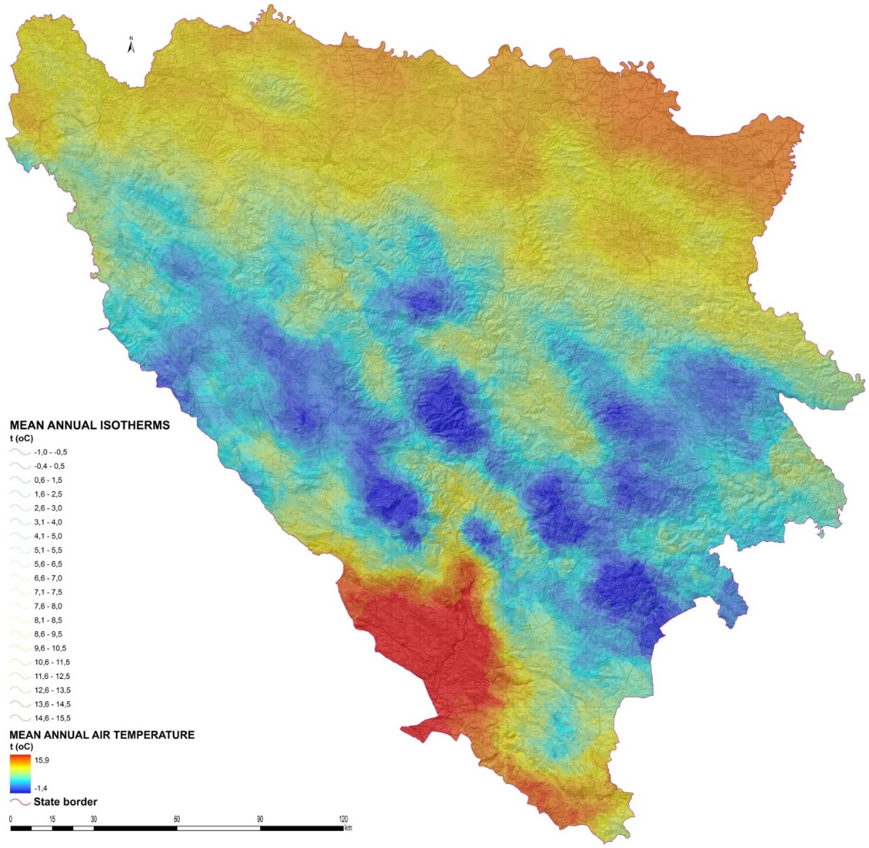

Fig. 5: Annual isotherms in Bosnia and Herzegovina.

Based on the stated schedule of extremes within the course of annual air temperatures it can be concluded that in Bosnia and Herzegovina as well as in the wider region the temperate latitudes climate type is predominantly represented. Furthermore, since Bosnia and Herzegovina is located in the northern temperate climate zone, with four clearly distinct climate periods, the above mentioned climate type can further be identified as temperate latitudes real type (Drešković 2011, 94). It should also be highlighted that, in accordance with macro terrain elements, this climate type in Bosnia and Herzegovina occurs in two varieties: continental and maritime, located in the predominantly continental or maritime regions respectively.
References

Drešković, N., Mirić, R. 2016: Horizontal air temperature changes as a basis for the regional climate differentiation of Bosnia and Herzegovina. Geografski pregled No.37 ; Year 2016. ISSN: 2303-8950.
Drešković, N. 2015: Spatial distribution of annual rainfall in Bosnia and Herzegovina using Spatial Kriging Interpolator. Geographical review. Scientific journal for geography, No. 36. Geographical society in Federation of Bosnia and Herzegovina and Department of Geography, Faculty of Science, University of Sarajevo. Pp: 95 – 107.
Drešković, N., Mirić, R. 2014: Climate regionalization of Bosnia and Herzegovina. Collection of papers III Congress of geographers in Bosnia and Herzegovina. Special editions of the Geographical society in F BiH, Sarajevo. Pp: 280 – 294.
Drešković, N., and Đug, S. 2012: Applying the Inverse Distance Weighting and Kriging methods of the spatial interpolation on mapping the annual precipitation in Bosnia and Herzegovina. International Environmental Modeling and Software Society (iEMSs) 2012 International Congress on Environmental Modeling and Software Managing Resources of a Limited Planet, Sixth Biennial Meeting, Leipzig, Germany R. Seppelt, A.A. Voinov, S. Lange, D. Bankamp (Eds.). (Each paper has been peer reviewed by at least two independent reviewers. ISBN: 978-88-9035-742-8)
Drešković, N. 2011: Climate types of Bosnia and Herzegovina: Doctor’s thesis. Sarajevo: Natural sciences faculty of the University.
Mirić, R., Drešković, N., Hrelja, E., Avdić, B. 2015: Regional and local hazards in tourism – case study of mine fields in the protected areas of Canton of Sarajevo. Book of proceedings 1st International Tourism and Hospitality Management Conference (Sarajevo, 30th September – 4th October 2015).

THERMAL REGIME OF ANNUAL AIR TEMPERATURE IN BOSNIA AND HERZEGOVINA
Summary

The paper analyzes the thermal regime of annual air temperature in Bosnia and Herzegovina. For the needs of defining quantitative thermal values, GRID is a thermal model of the hori-zontal change in the annual air temperature of 20 m spatial resolution. The thermal model of the annual air temperature flow was constructed on the basis of instrumental monitoring at 107 meteorological stations using DEM for Bosnia and Herzegovina for the validation of data. An analysis of this model showed that the mean annual air temperature for the territory of Bosnia and Herzegovina is 10.9 °C, while the continental part is about 9.7 °C, in the Mediterranean climate zone the stated value is 12.1 °C. A transverse and longitudinal thermal profiles were constructed to examine the horizontal temperature distribution. The transverse thermal profile was pulled from the middle of the Maloston channel to the mouth of the Drina River in the Sava River. The total length of the airline line is about 262.5 km, with the length of the topographic profile being higher. From the transversal profile chart, it is possible to determine the variation of the average temperature along the profile zone in the range of 3.0 °C to 15.5 °C, and the average vertical gradient is 0.55 °C / 100 m.

The longitudinal thermal profile is withdrawn from the northwest from the top of the mountain Maglić to the settlement Ponikve (the valley of the river Glina). Given that this profile line passes through the Dinaric direction through Bosnia and Herzegovina, its air length is larger and it is about 317 km. The temperature variation range along the longitudinal profile zone varies more - from 1.5 °C to 14.5 °C. In the course of the year, the air temperature in the entire territory of Bosnia and Herzegovina has determined the existence of only one outstanding temperature maximum and minimum, which averaged one month after the solar solstices. Maximum air temperatures occur in July. The exception to this rule refers to the zones of the highest mountain peaks, since at altitudes above 1,900 m above sea level, the temperature maximums are temporarily shifted to the month of August. A similar situation exists when it comes to minimal temperature extremes, since they are timed to the winter climatic period, i.e. December - February. Minimal air temperatures occur in January, but they move in the highest mountain zones (above the height limit) to the month of February. According to the noted, the quantitative values of the isotherms are annually found between the January and July extremes, respectively, ranging within the range of 15.5 °C to -1.0 °C. On the basis of the above values, the thermal differentiation of the Bosnian-Herzegovinian space into the characteristic thermal classes, which have special significance for the bioclimatic regionalization of Bosnia and Herzegovina, has been carried out. The first thermal class incorporates areas with a negative average annual temperature: from -1.4 °C to 0.0 °C. The area with negative mean annual temperatures is limited to narrow areas of the highest mountain peaks in the area of the southeastern Bosnian highlands. Positive average annual air temperatures are defined with three thermal grades: from 0.0 °C to 5.0 °C, 5.0 °C to 10.0 °C and from 10.0 °C to 15.9 °C. The above three thermal classes include hypsometric zones from 0 m to 2,200 m above sea level, which is over 95% of the total area of Bosnia and Herzegovina.

